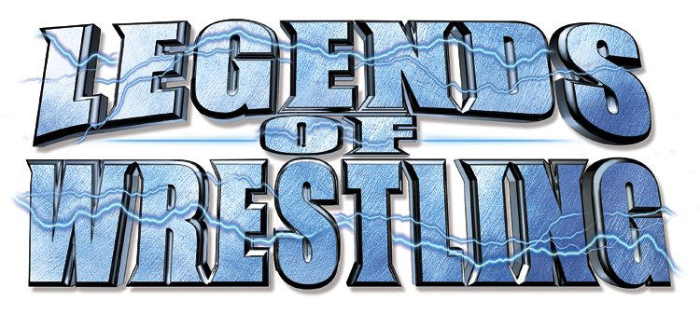Publisher: Acclaim Entertainment
Developer: Acclaim Studios Salt Lake City
Platform: Xbox™
ESRB Rating:‘T’ for Teen
Shipping: May 2002
PR Contact: Alan Lewis
Acclaim Entertainment
(516) 656-5000
alewis@acclaim.com

PRODUCT OVERVIEW
Legends of Wrestling is the first-ever wrestling game to take the greatest superstars of all-time and throw them into one game to find out who is the true king of kings.

PRODUCT FEATURES
Over 40 of the squared circle’s best including Hulk Hogan, Bret “Hitman” Hart, Jerry “The King” Lawler, Rob Van Dam, Terry Funk, The Road Warriors, Jimmy “Superfly” Snuka, King Kong Bundy, Ricky “The Dragon” Steamboat, George “The Animal” Steele and many more! Legends of Wrestling also features:
- Brand new game engine designed, developed and delivered exclusively for use on the next-generation hardware platforms;
- Revolutionary Intermediate Start Position (ISP) System, which enables players to link moves together for lethal single-button combinations and superior gameplay;
- First-ever “Create-a-Legend” enables the deepest wrestler customization in the history of wrestling videogames;
- First-ever in-depth match analysis and career guidance by wrestling’s greatest managers, including Captain Lou Albano and “The Mouth Of The South” Jimmy Hart;
- Bone-breaking matches, such as Three- and Four-Way Dances, and special guest referees;
- All-new, larger-than-life character models bring the greatest wrestlers and their signature moves into the ring for hours of fun;
- Interactive wrestler entrances with announcer introductions, crowd responses and authentic taunts;
- All-new Singles and Tag-Team career mode that takes players across the United States and throughout the world to battle for wrestling’s top titles;
- Wrestle in and out of the ring, with 10 venues and all-new weapons;
- All-new “Create-a-Stencil” lets players add logos, tattoos and text to the ring attire of their favorite legends, as well as Acclaim’s signature “Create-a-Stable” feature;
- TV broadcast presentation with all-new camera angles and cut scenes, delivering the best views of the heart-pounding action.

